BASIC MOM INFO

is a space probe orbiting Mars.

It was launched on 5 November 2013, at Satish Dhawan Space Centre (Sriharikota), using a Polar Satellite Launch Vehicle (PSLV) rocket C25 by the Indian Space Research Organisation (ISRO, the fourth space agency to reach Mars).

India's first interplanetary mission

Made India the first Asian nation to reach Martian orbit and the first nation in the world to do so on its maiden attempt

FLOW OF MISSION

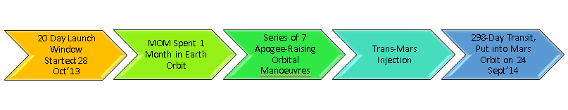

OVERVIEW/CONCLUSION

Specifically, if u r asking about classical mechanics…then everything, every step, even starting from the word itself - “journey to the mars” classical mechanics starts its action.

As we all know Classical mechanics is the study of the motion of bodies ,of which Circular motion by which a body executes a circular orbit about another fixed body, 2 body central force problem,the law of orbits,Keplers Law Governing the PLanetory Motion .

The orbital motion between sun and mars ,along with the earth’s motion is considered in such a way that our MOM should be injected to finally lock to orbit around mars. this type of opportunity we get roughly once in 2 years ,also the journey from earth to mars would take around 300 days

So, the Journey to be travelled by the rocket-

its build up, trajectory, motion, proppelling system, finding out its suitable orbit, escape velocity everything has got to seek help of classical mechanics.

On the other hand, relation of mars,earth and suns motion, its location at certain time, its rotation, revolution, gravity which plays major role in fixing orbit for the ship, landing technique, descent speed, exhaust force too demand concepts of classical mechanics.

The orbit will be an ellipse since E is Negative.The Centre OF Earth act as One Of the Foci.

Acc to 2 Body Central Force Problem(Concept of Classical Mechainics);

Elliptic orbit - An orbit with an eccentricity greater than 0 and less than 1 whose orbit traces the path of an ellipse.

Geocentric phase (“Earth orbit” involves any object orbiting the Earth)

Heliocentric phase (“circumsolar orbit” is an orbit around the barycenter of the Solar System, which is usually located within or very near the surface of the Sun.)[ Trans-Mars injection]

An Areocentric phase (“Mars Orbit” is an orbit around the planet Mars)

MISSION PROFILE

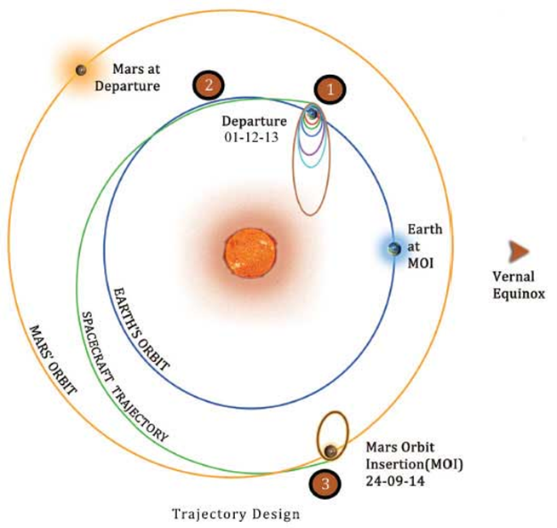

CLASSICAL MECHANICS

When used to move a spacecraft from orbiting one planet to orbiting another, the situation becomes somewhat more complex, but much less delta-v is required, due to the Oberth effect, than the sum of the delta-v required to escape the first planet plus the delta-v required for a Hohmann transfer to the second planet.

For example, consider a spacecraft travelling from the Earth to Mars. At the beginning of its journey, the spacecraft will already have a certain velocity and kinetic energy associated with its orbit around Earth. During the burn the rocket engine applies its delta-v, but the kinetic energy increases as a square law(Concept of Classical Mechanics), until it is sufficient to escape the planet's gravitational potential, and then burns more so as to gain enough energy to get into the Hohmann transfer orbit (around the Sun). Because the rocket engine is able to make use of the initial kinetic energy of the propellant, far less delta-v is required over and above that needed to reach escape velocity, and the optimum situation is when the transfer burn is made at minimum altitude (low periapsis) above the planet. The delta-v needed is only 3.6 km/s, only about 0.4 km/s more than needed to escape Earth, even though this results in the spacecraft going 2.9 km/s faster than the Earth as it heads off for Mars (see table below).

At the other end, the spacecraft will need a certain velocity to orbit Mars, which will actually be less than the velocity needed to continue orbiting the Sun in the transfer orbit, let alone attempting to orbit the Sun in a Mars-like orbit. Therefore, the spacecraft will have to decelerate in order for the gravity of Mars to capture it. This capture burn should optimally be done at low altitude to also make best use of Oberth effect. Therefore, relatively small amounts of thrust at either end of the trip are needed to arrange the transfer compared to the free space situation.

However, with any Hohmann transfer, the alignment of the two planets in their orbits is crucial – the destination planet and the spacecraft must arrive at the same point in their respective orbits around the Sun at the same time. This requirement for alignment gives rise to the concept of launch windows.

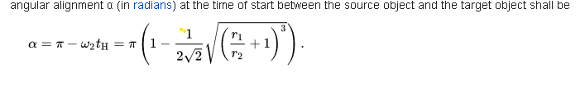

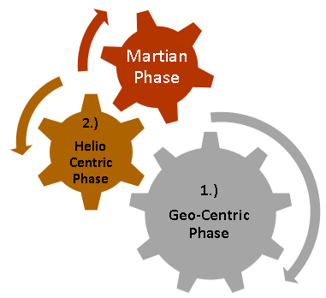

1. Geo Centric Phase

The spacecraft is injected into an Elliptic Parking Orbit by the launcher. With six main engine burns, the spacecraft is gradually maneuvered into a departure hyperbolic trajectory with which it escapes from the Earth’s Sphere of Influence (SOI) with Earth’s orbital velocity + V boost.

The SOI of earth ends at 918347 km from the surface of the earth beyond which the perturbing force on the orbiter is mainly due to the Sun.

One primary concern is how to get the spacecraft to Mars, on the least amount of fuel. ISRO uses a method of travel called a Hohmann Transfer Orbit – or a Minimum Energy Transfer Orbit – to send a spacecraft from Earth to Mars with the least amount of fuel possible.

A geocentric orbit or Earth orbit involves any object orbiting the Earth, such as the Moon or artificial satellites

A spacecraft enters orbit when its centripetal acceleration due to gravity is less than or equal to the centrifugal acceleration due to the horizontal component of its velocity.

Spacecraft with a perigee below about 2,000 km are subject to drag from the Earth's atmosphere, which decreases the orbital altitude. The rate of orbital decay depends on the satellite's cross-sectional area and mass, as well as variations in the air density of the upper atmosphere.

The escape velocity required to pull free of Earth's gravitational field altogether and move into interplanetary space is about 11,200 m/s.

Escape Trajectory - This trajectory must be used to launch an interplanetary probe away from Earth, because the excess over escape velocity is what changes its heliocentric orbit from that of Earth.

2. Helio Centric Phase

The spacecraft leaves Earth in a direction tangential to Earth’s orbit and encounters Mars tangentially to its orbit. The flight path is roughly one half of an ellipse around sun.

Eventually it will intersect the orbit of Mars at the exact moment when Mars is there too. This trajectory becomes possible with certain allowances when the relative position of Earth, Mars and Sun form an angle of approximately 44o. Such an arrangement recur periodically at intervals of about 780 days. Minimum energy opportunities for Earth-Mars occur in November 2013, January 2016, May2018 etc.

Hohmann transfer orbit - An orbital maneuver that moves a spacecraft from one circular orbit to another using two engine impulses.

***Trans-Mars injection***

A trans-Mars injection (TMI) is a heliocentric orbit in which a propulsive maneuver is used to set a spacecraft on a trajectory, also known as Mars transfer orbit, which will place it as far as Mars's orbit.

Every two years, low-energy transfer windows open up, which allow movement between planets with the lowest possible delta-v requirements.

Transfer injections can place spacecraft into either a Hohmann transfer orbit or bi-elliptic transfer orbit. Trans-Mars injections can be either a single maneuver burn, such as used by the ISRO Mars Orbiter Mission.

3. Martian Phase

The spacecraft arrives at the Mars Sphere of Influence (around 573473 km from the surface of Mars) in a hyperbolic trajectory. At the time the spacecraft reaches the closest approach to Mars (Periapsis), it is captured into planned orbit around mars by imparting ∆V retro which is called the Mars Orbit Insertion (MOI) manoeuvre.

The Earth-Mars trajectory is shown in the above figure. ISRO plans to launch the Mars Orbiter Mission during the November 2013 window utilizing minimum energy transfer opportunity.

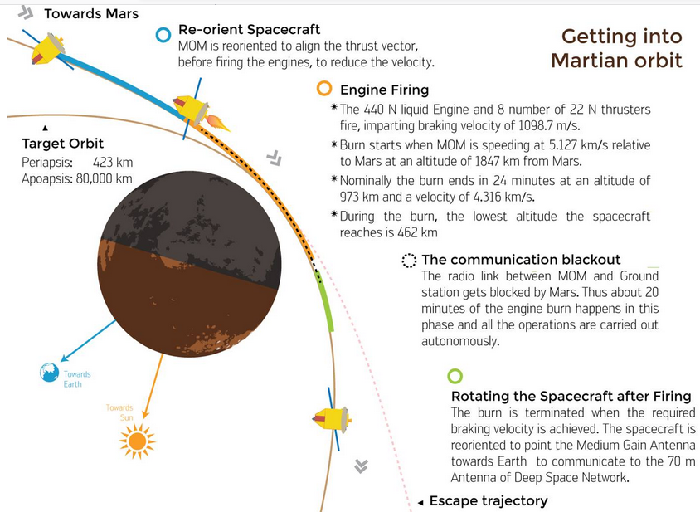

An areocentric orbit is an orbit around the planet Mars.

Formula

Orbital speed (how fast a satellite is moving through space) is calculated by multiplying the angular speed of the satellite by the orbital radius:

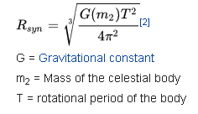

By this formula one can find the geostationary-analogous orbit of an object in relation to a given body, in this case, Mars, Areostationary orbit can be defined as approximately 17,032 km above the surface of the Mars equator after substituting all values.

FUEL SAVED BY CLASSICAL MECH CONCEPT(finding out its suitable orbit)

Launch opportunities for a fuel-saving Hohmann transfer orbit (an elliptical orbit used to transfer between two circular orbits of different radii around the same body in the same plane ) occur every 26 months.

The Hohmann transfer orbit uses the lowest possible amount of energy in traveling between these orbits.